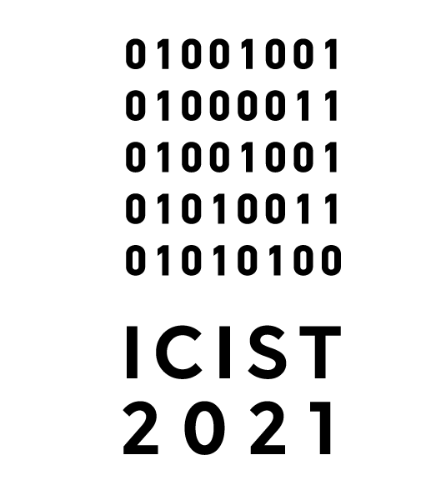

- To submit a paper, please log in to EasyChair ICIST 2021 event. After logging, you can submit your manuscript under the preferred special session.

- The paper’s size should not exceed 5000 words and 12 pages (fee for extra pages is 10 EUR per page).

- The accepted papers will be published as a volume of Springer-Verlag CCIS (Communications in Computer and Information Science) series. CCIS is indexed in ISI Proceedings and Scopus. Conference proceedings are rated as Level 1 periodical publication in Norwegian system.

- One of the authors of each paper accepted for publishing in CCIS will have to register and present the paper at the conference. Note that no more than two papers by the same author (written individually or with the coauthors) can be included in this particular volume. Authors should submit a paper which is prepared for the conference and has not been published in any journal or conference proceedings.

- Accepted for publication manuscript should be revised considering remarks of the reviewers. A revised version of an article should be submitted as a review version. Corrections done must be marked in other text colour.

- All accepted papers will have to be formatted in accordance to the Springer requirements. Please see the templates and other important downloads for authors. Papers submitted will be reviewed by two reviewers and in case of disagreement of them, a third independent reviewer will be involved.

- Paper reviewing process is double-blind, therefore before submitting the paper, please remove the names of authors from the title page (as well as obvious references to the authors in the text, if there are any). Also please edit the reference list in a way that it has got no works by the authors of the paper (such items in the list should be left blank, with only an original number and no text). The aforementioned information has to be restored when submitting the camera ready version.

- Authors are advised not to shorten the references and to put DOIs wherever possible, as this would allow for correct citation attribution.

- Please do not use password protection in a submitted manuscript or include headers and footers in the manuscript.

