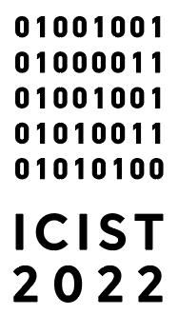

This page contains information for scholars presenting papers at ICIST Annual Conference. Please remember these are suggested guidelines intended to be helpful on a voluntary basis; they are not strict rules and practices may vary among the various sections and working groups.

- The official language of the ICIST 2022 is English.
- Equipment that will be given: PC (Microsoft Windows and MS Office 2018) and Projector. Note: it only applies if the presentation takes place in-person.
- You should bring your presentation on a USB stick and upload it on Desktop before the session starts.
- Time limit and presentation form:
  - Key Notes: up to an hour, including discussion.
  - A slide presentation is recommended to take 15 minutes leaving an author 5 minutes to answer the questions.
  - Going over the time limit only prevents further discussion (it cuts into the session's time, which cannot be extended), and is disrespectful to the other presenters and the audience.
- Since presentations will be delivered in large lecture halls, it is recommended to prepare your slides accordingly.
  - Font size: 32 pt for titles, 28 pt (minimum 24 pt) for the main body.
  - Spacing: a minimum of 5mm of blank space between lines.
- It is often helpful for presenters to have hard copies of their papers available to distribute to interested audience members.
- Remember that you can expand your presentation giving a speech, and only essential information should be presented in slides.
- If a presenter wishes to read from a short presentation script, here are some rough guidelines. For presenters reading scripts: 300 words of typed text takes about 2 minutes to read. Also, presenters should look up every so often to make eye contact with the audience and especially with the session chair who will be giving time signals during the presenter’s allotted time.

